CREATE TABLE employee3(

empid int primary key,

empname VARCHAR(64),

basicpay int,

conveyance int,

netsalary int

);

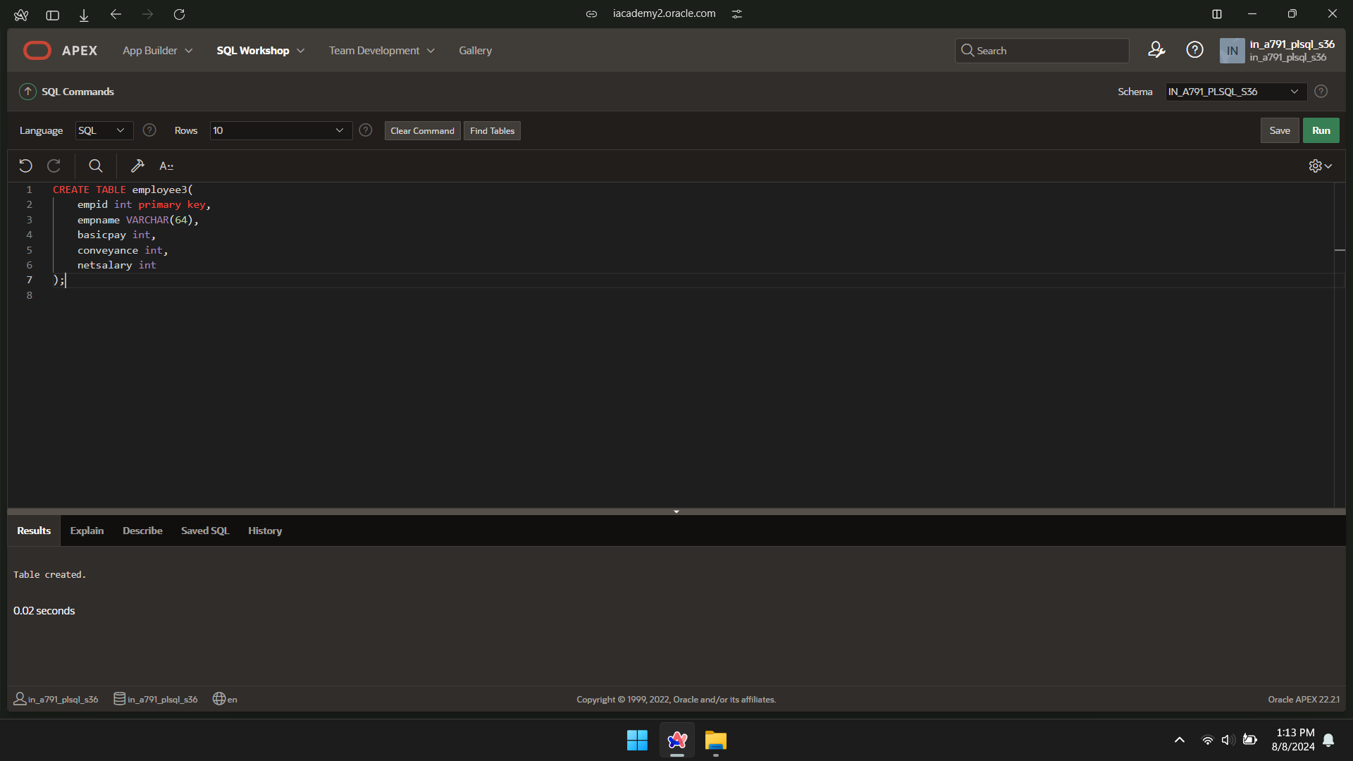

INSERT INTO employee3(empid,empname,basicpay) VALUES(100,'name1',64500);

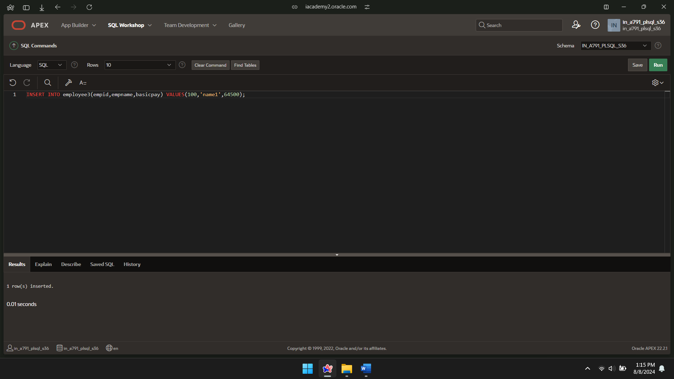

INSERT INTO employee3(empid,empname,basicpay) VALUES(101,'name2',78200);

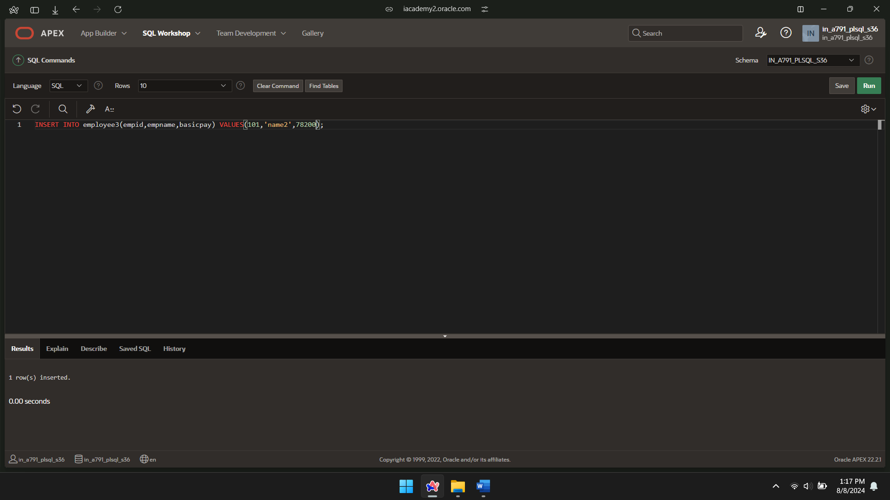

INSERT INTO employee3(empid,empname,basicpay) VALUES(102,'name3',54300);

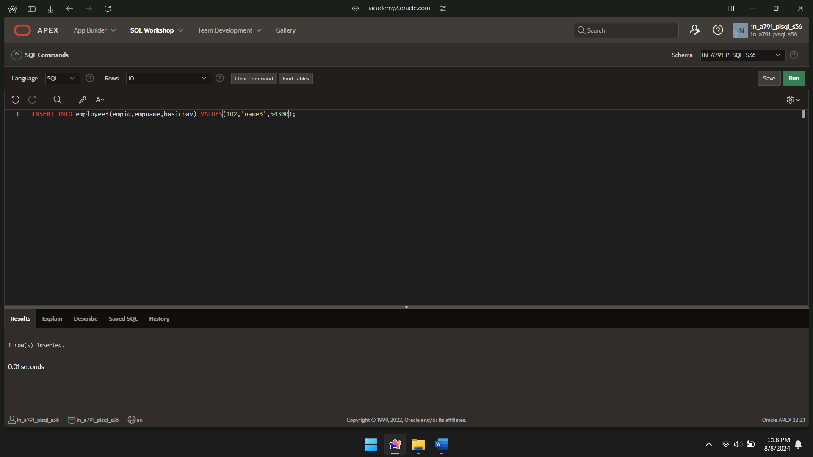

INSERT INTO employee3(empid,empname,basicpay) VALUES(103,'name4',49800);

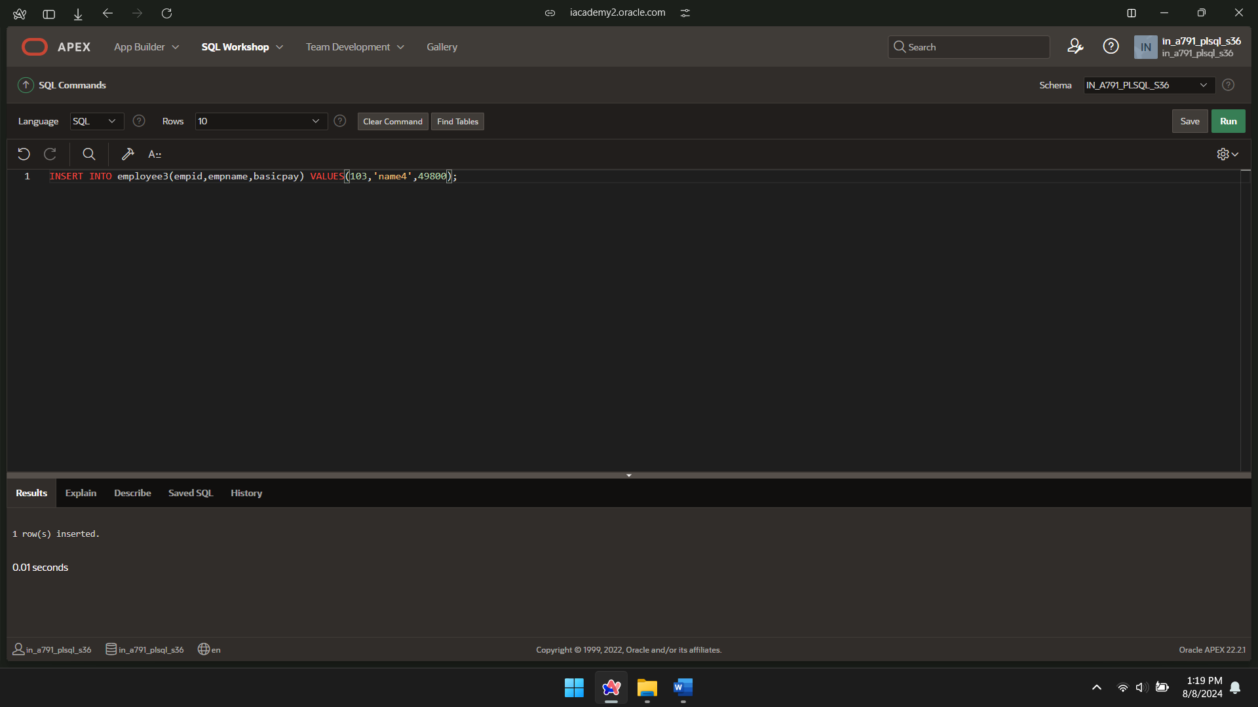

SELECT\*FROM employee3;

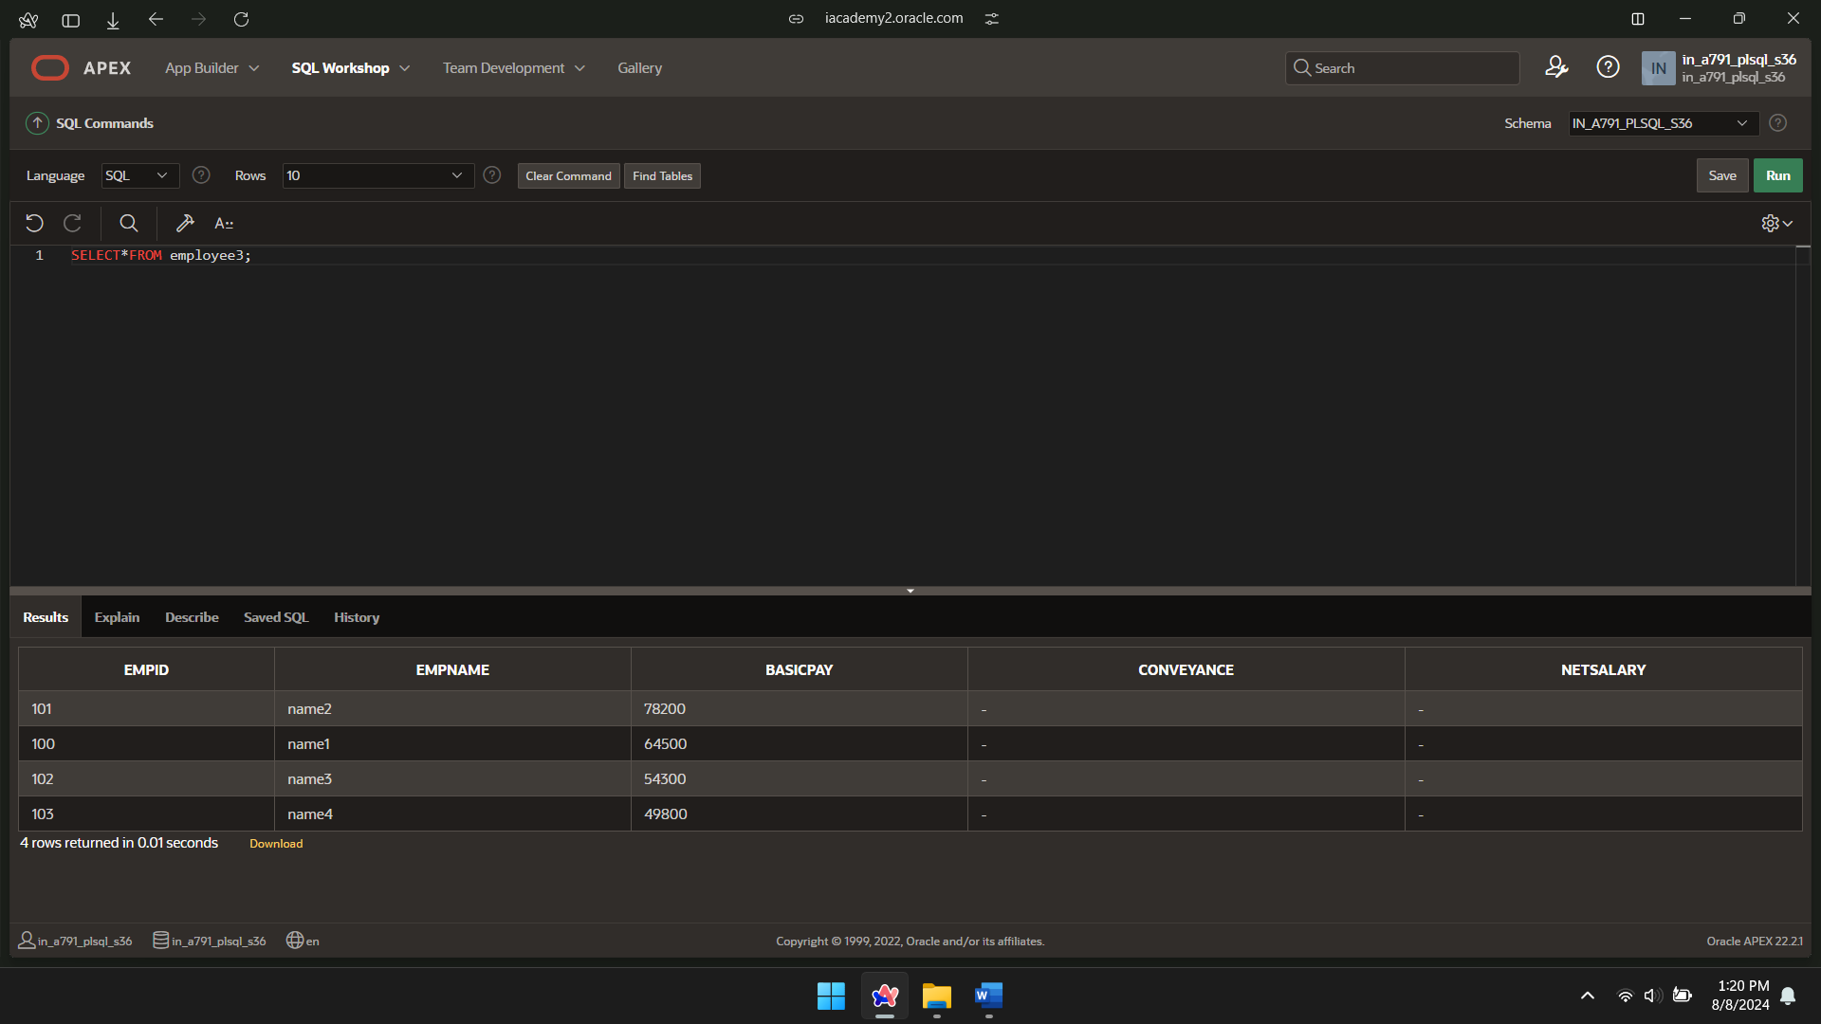

CREATE OR REPLACE PROCEDURE conveyanceallow

IS

BEGIN

UPDATE employee3

SET conveyance = basicpay \* 0.2;

END conveyanceallow;

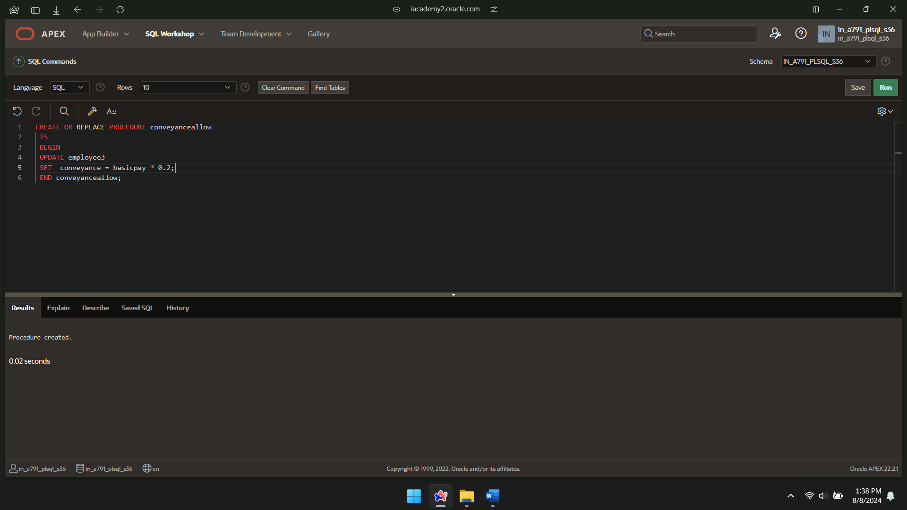

BEGIN conveyanceallow;

END;



SELECT\*FROM employee3;

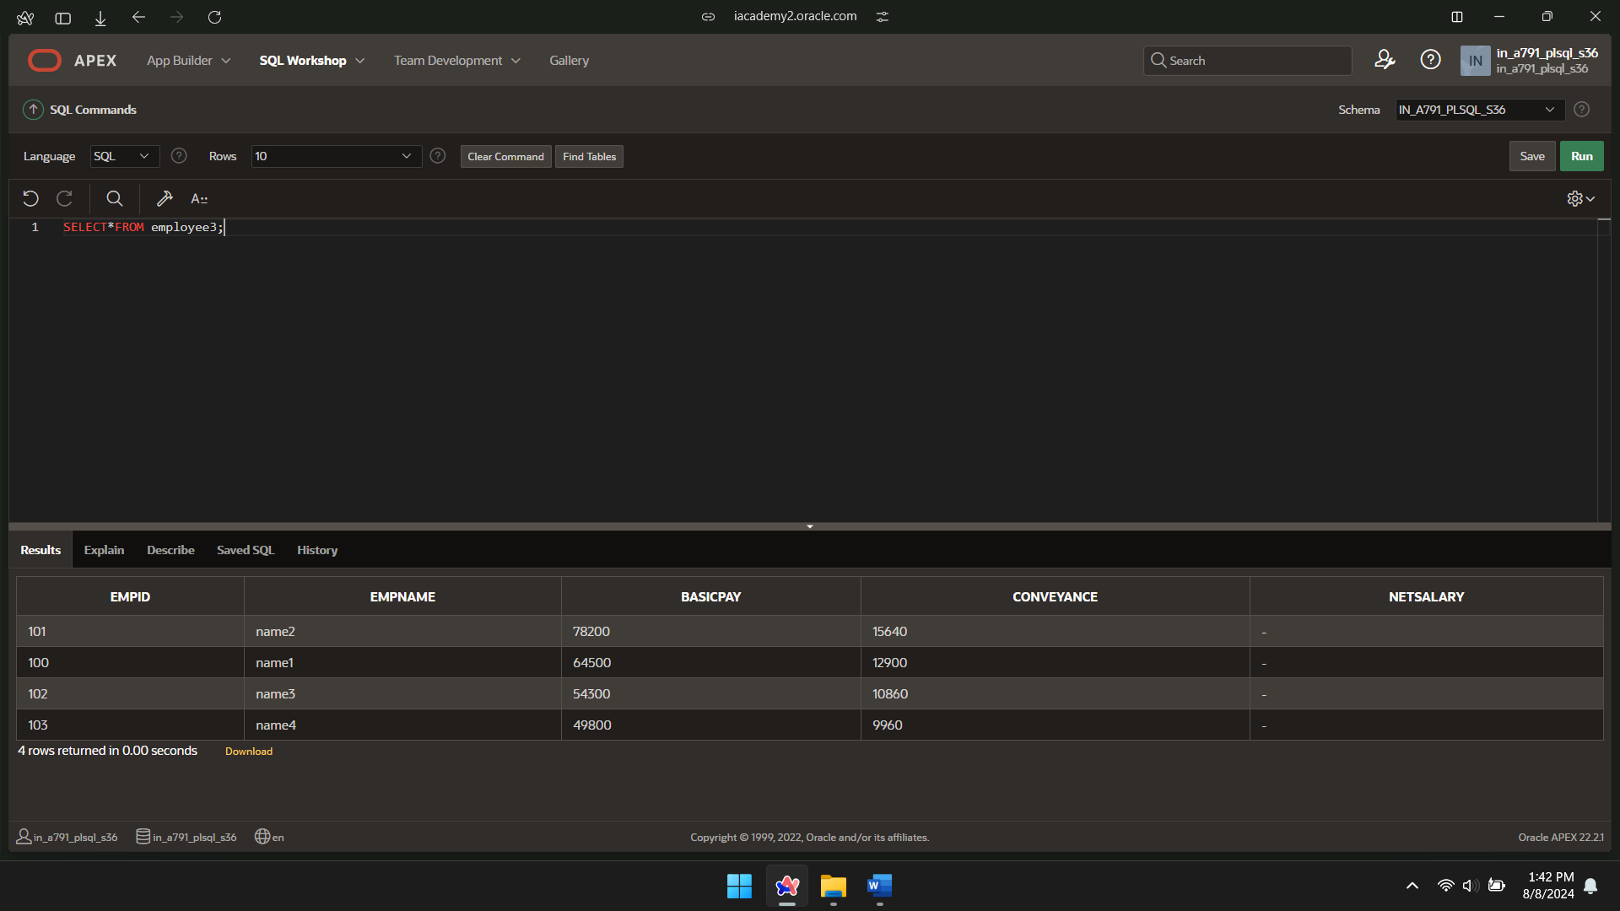

CREATE OR REPLACE PROCEDURE netsal

IS

BEGIN

UPDATE employee3

SET netsalary=basicpay+conveyance;

END netsal;

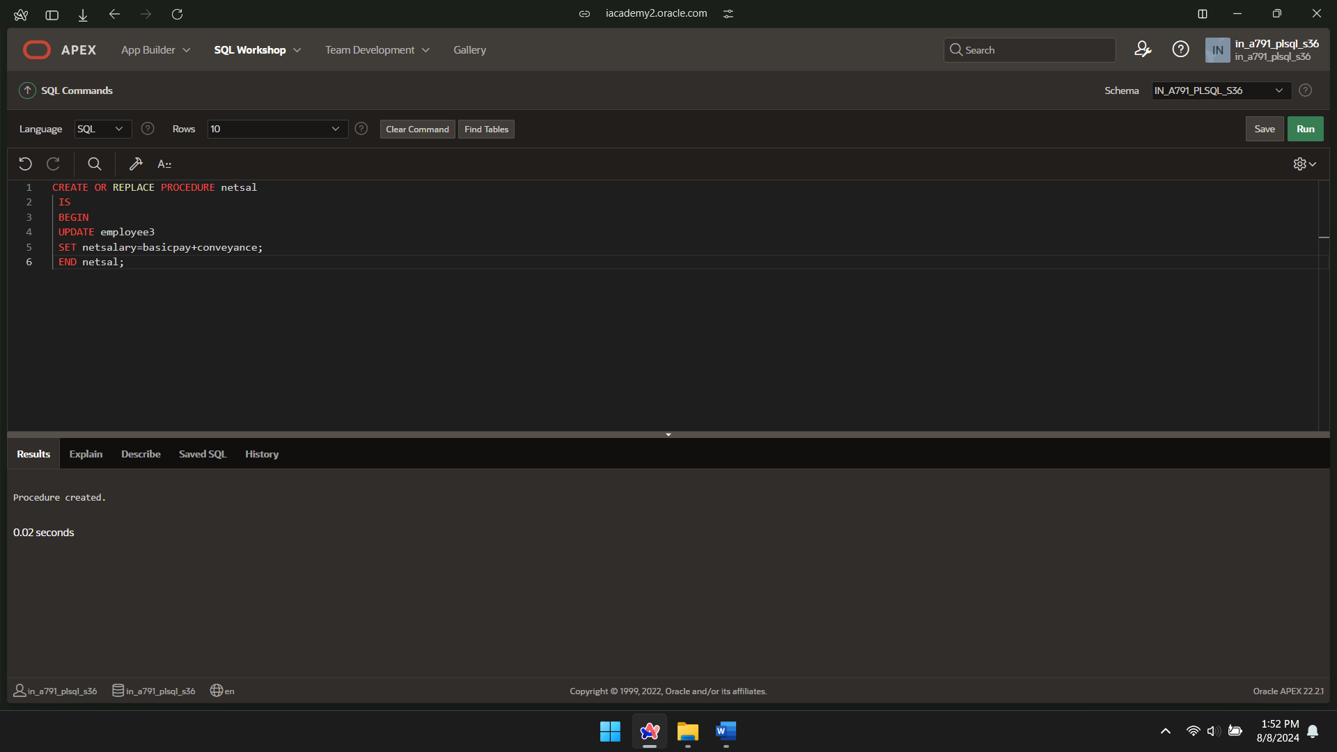

BEGIN netsal;

END;



SELECT\*FROM employee3;

